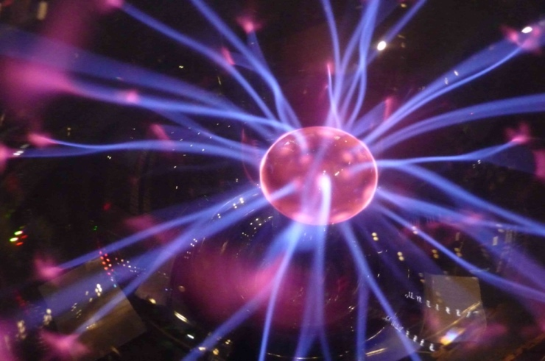
Plasma Ball

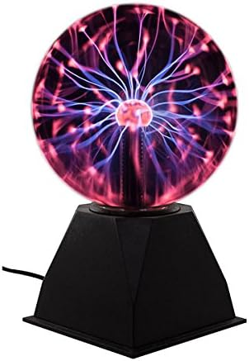
Glass sphere with helium, neon, argon, or other gases inside.

High voltage power supply is used to separate electrons from atoms, thus producing ions plus electrons, or plasma.

